Sub alphabetical_testing()

'Create a script that will loop through each year of stock data and grab the total amount of volume each stock had over the year.

'You will also need to display the ticker symbol to coincide with the total volume.

'Identifying Variables:

Dim Ticker As String

Dim Total_Stock_Volume As LongLong

Dim Summary_Table_Row As Integer

'Total_Stock_Volume:

Total_Stock_Volume = 0

'Insert Headers for Column 9 & 10:

For Each ws In Worksheets

ws.Cells(1, 9).Value = "Ticker"

ws.Cells(1, 10).Value = "Total Stock Volume"

'Knowing the Last Row:

LastRow = ws.Cells(Rows.Count, 1).End(xlUp).Row

Summary_Table_Row = 2

'Looping through Stocks:

For i = 2 To LastRow

'Conditionals:

If ws.Cells(i + 1, 1).Value <> ws.Cells(i, 1).Value Then

'Ideitify Tickers

Ticker = ws.Cells(i, 1).Value

'Calculation of Total Stock Vol.

Total_Stock_Volume = Total_Stock_Volume + ws.Cells(i, 7).Value

'Input result in Summary Table

ws.Range("I" & Summary_Table_Row).Value = Ticker

ws.Range("J" & Summary_Table_Row).Value = Total_Stock_Volume

'Add one to the Summary Table:

Summary_Table_Row = Summary_Table_Row + 1

'Reset for ticker:

Total_Stock_Volume = 0

Else

Total_Stock_Volume = Total_Stock_Volume + ws.Cells(i, 7).Value

End If

Next i

Next ws

End Sub

**_____________________________________________________________________________________**

**Year 2014**

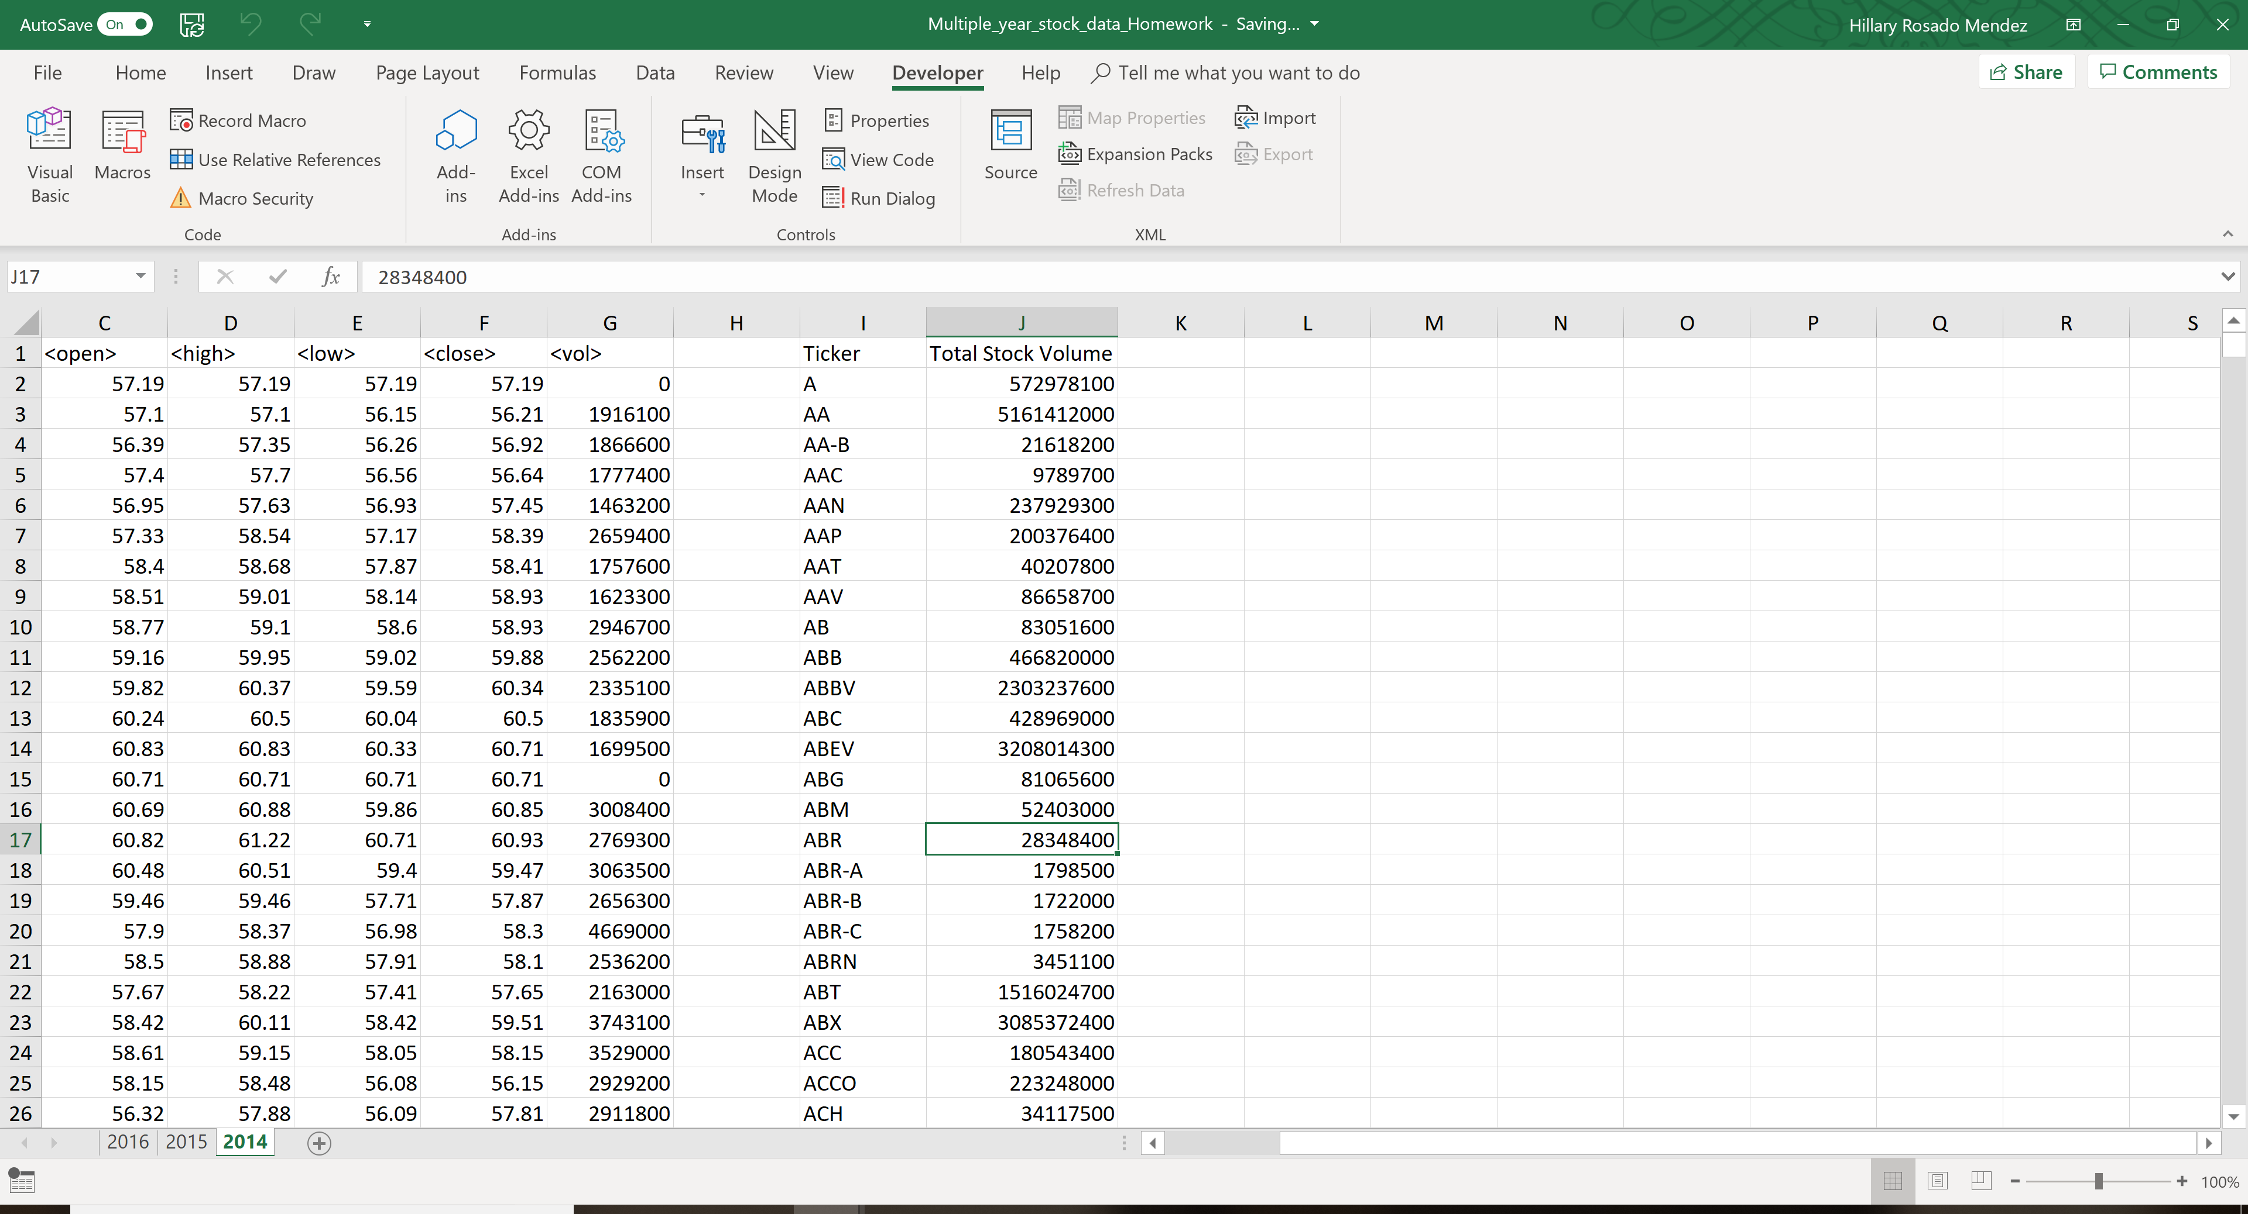

**Year: 2015**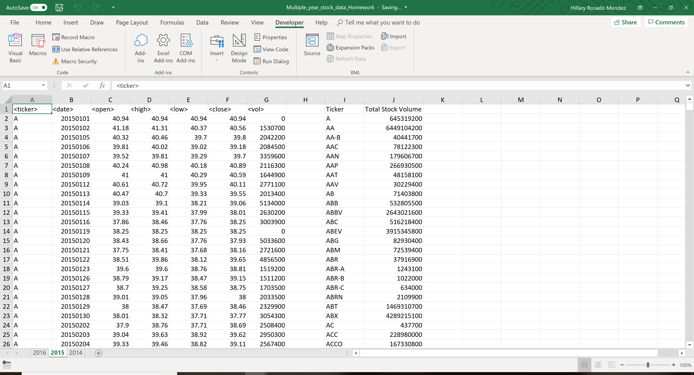

**Year: 2016**

